STUDENT INFORMATION & ENROLLMENT MANAGEMENT INTEGRATED SYSTEM

(SUBSYSTEM)

A Project Document Study

Presented to the Faculty of the Bachelor of Science in Information Technology

In Partial Fulfillment of the Requirements

for the Subject Information Assurance and Security 2

By:

Ferdinand G. Espeña Jr.
Jhon Lesther S. Monleon
Aldrex M. Cordon
Meryl Longares
Justin Quinsay

BSIT - 3201

Name of Institution Month Year

TABLE OF CONTENTS

PROJECT PROFILE....................................................................................... X

EXECUTIVE SUMMARY................................................................................. X

INTRODUCTION............................................................................................. X

Background of the Study........................................................................ X

Statement of the Problem....................................................................... X

Project Objectives................................................................................... X

Significance of the Study........................................................................ X

Scope and Limitations............................................................................ X

FRAMEWORK............................................................................................... X

SYSTEM ANALYSIS..................................................................................... X

Existing System Analysis...................................................................... X

Threat and Risk Assessment................................................................ X

Security Requirements Analysis........................................................... X

Proposed Secure Integrated System.................................................... X

SYSTEM DESIGN......................................................................................... X

Secure System Architecture................................................................. X

Network and Application Security Design........................................... X

Database and Data Security Design..................................................... X

Access Control Design.......................................................................... X

Audit and Logging Design..................................................................... X

SYSTEM MODULES AND FUNCTIONAL FEATURES................................ X

DEVELOPMENT METHODOLOGY............................................................... X

Secure SDLC........................................................................................... X

Tools and Technologies......................................................................... X

SYSTEM DIAGRAMS.................................................................................... X

TESTING AND EVALUATION....................................................................... X

Security Testing...................................................................................... X

Evaluation Criteria.................................................................................. X

RISK MANAGEMENT AND INCIDENT RESPONSE................................... X

Risk Management Plan.......................................................................... X

Incident Response Plan......................................................................... X

PROJECT SCHEDULE / TIMELINE.............................................................. X

COST AND RESOURCE REQUIREMENTS................................................. X

EXPECTED OUTPUTS AND BENEFITS...................................................... X

CONCLUSION AND RECOMMENDATIONS................................................ X

REFERENCES............................................................................................... X
I. PROJECT PROFILE

1. Project Title
Design and Development of a Secure Integrated Human Resource Management System (HRMS)
This title specifies the type of system, implies the target users (HR personnel, employees, and administrators), and highlights the key function while incorporating a security context required for IAS.

2. Integrated System
The HRMS integrates critical human resource processes — specifically employee profiling and leave management — into a single centralized platform. Manual processes such as tracking 201 records, maintaining spreadsheets, and processing physical leave request forms are fully automated. This integration drastically improves operational efficiency, reduces administrative overhead, and enhances data security. Role-based access ensures that employees can safely request leave while supervisors and HR managers have the authorized overviews needed to approve requests and manage compensation.

3. Sub-Systems
- Employee Management Sub-System
Responsible for onboarding and managing detailed records for employees, including custom attributes, job titles, and pay grades. It ensures all employee data is centralized in one secure, queryable location.
- Leave Management Sub-System
Automates the entire lifecycle of leave workflows, from an employee submitting a request to a supervisor approving or rejecting it, complete with real-time notifications and tracked audit trails.
- Security and Access Control Sub-System
Enforces Role-Based Access Control (RBAC), identifying users as Administrators, HR Managers, Supervisors, or Employees. It generates JWT tokens and leverages password hashing (bcrypt) to keep all accounts secure.
- Reporting and Analytics Sub-System
Provides data-driven analytics and structured overviews of employee data, attendance records, and leave balances, accessible to administrative accounts.

4. List of Modules
- Authentication & Role Module
◦ Handles login functionality, JWT token assignment, role validation, and password encryption.
- User Profile Module
◦ Allows employees to view their own profile and managers to update comprehensive employee metadata (NIC, DOB, dependents, emergency contacts).
- Leave Request Module
◦ Enables employees to file, monitor, and track leave applications in real time.
- Leave Approval Module
◦ Enables supervisors and managers to oversee pending leaves and handle approval workflows.
- Notifications Module
◦ Broadcasts system messages alerting users of leave statuses, approvals, rejections, and other system events.
- Compensation & Job Title Module
◦ Used by Administrators to define job structures and standard pay grade configurations.

II. EXECUTIVE SUMMARY

- Introduction and Context

In the rapidly evolving landscape of corporate operations, human capital remains the most critical asset of any organization. The efficient management of employee profiles, organizational hierarchies, and operational requests such as leaves of absence directly impacts the strategic agility and overall productivity of a company. However, historical and legacy paradigms—which rely heavily on physical paperwork, disconnected spreadsheets, and fragmented datastores—have persistently plagued human resources (HR) departments. Administrative bottlenecks naturally arise as data becomes redundant and inconsistently synchronized across multiple internal silos. More significantly, the lack of centralized digital record-keeping poses severe security vulnerabilities, exposing profoundly sensitive Personally Identifiable Information (PII) to both internal misuse and external data breaches. This pervasive reliance on legacy systems restricts agility and creates profound legal and compliance risks under modern data protection frameworks.

In direct response to these systemic inefficiencies, this project proposes the "Design and Development of a Secure Integrated Human Resource Management System (HRMS)." The finalized HRMS serves as a comprehensive, centralized digital platform intelligently engineered to overhaul, streamline, and secure the foundational pillars of HR operations: employee lifecycle management, automated leave tracking, and complex organizational configurations.

- Problem Identification and System Objectives

The foundational driver for this project is the urgent need to address the compounding detriments of manual HR processing. When leave applications are physically routed, they are frequently delayed or lost entirely. When employee records exist simultaneously in accounting, HR, and managerial spreadsheets, a "single source of truth" is rendered impossible, resulting in payroll inaccuracies. Worst of all, traditional physical folders inherently lack granular authorization constraints—a supervisor cannot effortlessly be restricted from viewing the compensation data of employees outside their department.

Therefore, the core objectives of this integrated system are meticulously targeted to automate the end-to-end leave management lifecycle, establish an irrefutable and secure centralized database, and provide instant, permissions-gated analytical capabilities. The system seeks to completely eradicate the administrative burden of dual data entry, thus allowing HR personnel to evolve from data clerks into strategic organizational partners. More critically, the project aims to construct a fortress of data integrity and confidentiality around all stored corporate intelligence.

- Technical Architecture and Secure Design

To completely satisfy the rigorous demands of modern corporate security and performance, the HRMS relies on a decoupled, client-server web architecture leveraging an advanced technological stack. The resilient frontend is engineered with React.js, furnishing an intuitive, responsive, and cross-platform compatible user interface ensuring flawless adoption by employees regardless of technical acumen. This client application securely communicates with a robust Node.js and Express.js backend Application Programming Interface (API), which is strategically isolated from public internet interference. At the data layer, a heavily normalized and securely clustered MySQL database serves as the unbreakable foundation for persistent storage, completely eradicating physical data redundancy.

- Security Prioritization and Implementation

As HR systems inherently house an organization's most sensitive data—including salaries, contact details, and hierarchical charts—security acts as the absolute cornerstone rather than an afterthought of this project. The system infrastructure strictly codifies the Principle of Least Privilege (PoLP). To achieve this, it structurally enforces robust Role-Based Access Control (RBAC), rigidly separating privileges among four universally defined archetypes: the global Administrator, the HR Manager, the operational Supervisor, and the base Employee.

Authentication into the digital portal is exclusively mediated through JSON Web Tokens (JWT), guaranteeing a tamper-proof and stateless verification mechanism explicitly guarding against session hijacking and Cross-Site Request Forgery (CSRF). Furthermore, to ensure absolute data confidentiality at rest, the platform enforces state-of-the-art cryptographic hashing relying on the Bcrypt algorithm, rendering databases functionally useless to any malicious actor attempting to compromise user credentials. System-wide integrity is finalized through automated audit trails—logging critical modifications to employee statuses or leave approvals—thus cultivating a transparent culture of digital accountability and non-repudiation.

- System Modules and Deliverables

The resulting platform culminates in several highly cohesive modules integrated smoothly under a single pane of glass. The Employee Lifecycle Management module permits authorized stakeholders seamless creation, updating, and retirement of employee profiles. Concurrently, the Automated Leave system provides a digital avenue for employees to submit time-off requests, which are programmatically routed to distinct supervisor dashboards for immediate approval or rejection via secure APIs—all while simultaneously calculating and validating remaining leave balances in real-time. Complimenting these features is the Systems Configurations and Analytics dashboard, an exclusive executive realm empowering decision-makers with live macro-views of the company structure, dynamic job roles, departmental distributions, and overarching attendance behaviors.

Expected Organizational Impact and Conclusion

By adopting and transitioning workflows into this fully integrated and secure digital ecosystem, the organization will experience an immediate transformation in administrative velocity. The platform directly translates into thousands of reclaimed man-hours previously lost to paper chasing, data reconciliation, and manual reporting. Most crucially, this deployment successfully mitigates profound institutional risks by migrating delicate personnel records into an encrypted, continuously backed-up, and meticulously audited data vault. Ultimately, the Design and Development of this Secure Integrated HRMS does not merely solve a logistical inconvenience—it provides a scalable, future-proof, and impenetrable technological asset that inherently elevates the organization's overarching operational efficiency and data stewardship capabilities.

III. INTRODUCTION

1. Background of the Study
Human Resource departments often struggle with legacy or manual processes such as relying on paper forms, standalone spreadsheets, and physical 201 files to manage their staff. These conventional methods are extremely slow, severely isolated from each other, and fundamentally insecure. Sensitive employee data is kept without rigid authorization parameters, making it inherently vulnerable to data loss and unauthorized disclosure. Moreover, tracking leave requests manually without a centralized record leads to inefficiencies, payroll errors, and miscommunications among departments. These operational roadblocks create an urgent need for an automated, secure, and integrated platform to replace outdated HR practices.

2. Statement of the Problem
The following specific problems are identified in the current HR system:
• Lack of a centralized and secure data storage framework, causing employee profiles and compensation records to be scattered across disconnected systems.
• Unauthorized access risks to confidential records due to the absence of strict role-based access restrictions.
• Inefficient and manual leave request processes that lack reliable audit trails and automated tracking mechanisms.

3. Project Objectives
General Objective
To design and develop a secure, web-based, integrated Human Resource Management System that centralizes employee records and streamlines the leave management process.
Specific Objectives
• Implement strict Role-Based Access Control (RBAC) to differentiate data access for Administrators, HR Managers, Supervisors, and Employees.
• Ensure data confidentiality and integrity by using JWT authentication protocols and password hashing (bcrypt).
• Automate the tracking of employee attendance and leave balances with auditable approval workflows.

4. Significance of the Study
The deployment of this integrated system provides tangible benefits for the following stakeholders within the organization:
• Employees – Benefit from a transparent system where they can easily submit leave requests and instantly track their status without manual follow-ups.
• Supervisors – Save time with streamlined approval pipelines and simple overviews of team attendance and leave history.
• HR Managers – Gain immediate access to centralized data, dramatically reducing the administrative burden of handling physical employee files.
• Administrators – Maintain total configuration control over organizational job structures and pay grades securely.

5. Scope and Limitations
Scope
The system covers end-to-end employee profiling, automated leave tracking, organizational configurations (including job titles and pay grades), and strict role-based access control for all system users.
Limitations
• Absolute internet dependency is required to access the web platform and the hosted database.
• Reliance on centralized PostgreSQL/MySQL hosting; offline data synchronization is not supported.
• Role permissions are fixed to the four defined tiers; custom role creation outside these tiers is not currently supported.

IV. FRAMEWORK

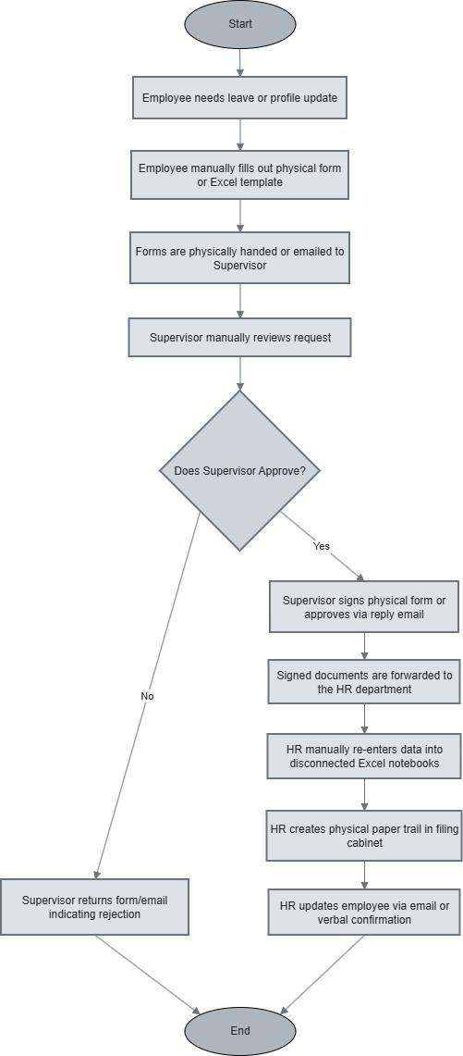
1. Existing Business Process

In the current workflow, employees manually fill out paper forms or spreadsheets to request leave or update personnel details. These documents are then physically routed or emailed to supervisors and HR staff. This physical and digital paper trail involves manual steps heavily reliant on trust, lacking robust authentication. The security weaknesses are glaring: physical documents can be intercepted or lost, and shared spreadsheets often grant overly broad permissions, making it easy for an unauthorized user to modify leave balances or view sensitive compensation data without leaving a traceable audit log.

2. Proposed Business Process
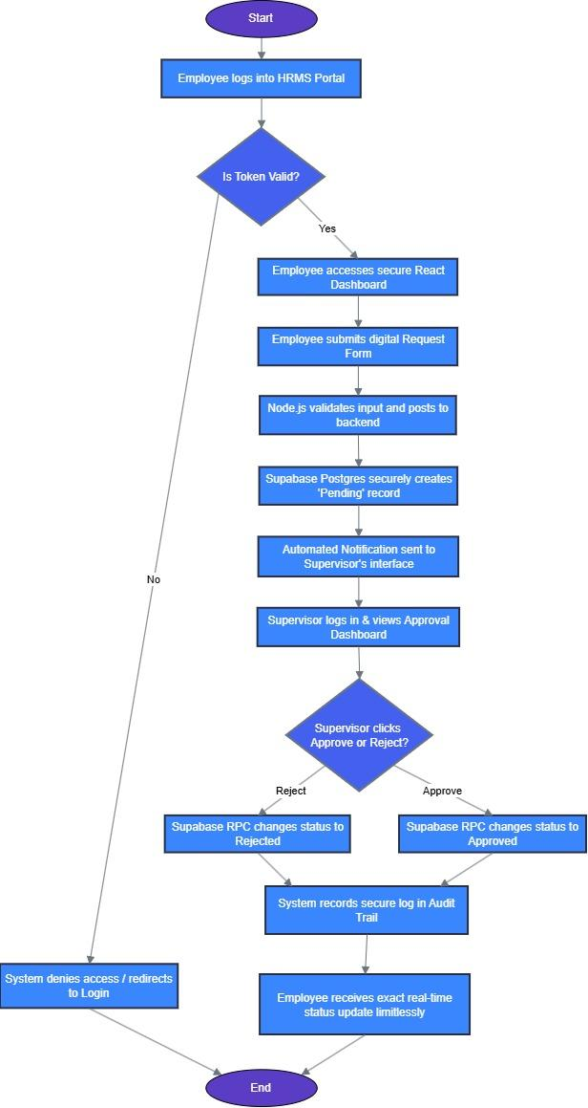
The improved workflow transitions all HR operations into a centralized, digitized system. When an employee attempts a transaction, they must first securely authenticate via JWT. Their request is systematically routed through automated processes direct to their authorized supervisor's dashboard. Supervisors execute approvals digitally over encrypted channels. Critical security checkpoints are embedded at every step: user roles are verified before any module is loaded, input validation guards against malicious data entry, and all modifications to personnel records are securely logged to an audit trail ensuring strict accountability and integrity.

V. SYSTEM ANALYSIS

1. Existing System Analysis
The current legacy HR infrastructure operates entirely on physical documents and disconnected spreadsheets. Its major operational limitations include the inability to instantly query employee data, heavy reliance on physical storage space, and a convoluted leave request process where forms must be physically routed and signed over several days. Its most critical risk is that physical documents and weakly protected spreadsheets possess no security constraints — any individual with physical or shared computer access can view or modify sensitive employee data.

2. Threat and Risk Assessment
Threats
• Insider threats from personnel browsing confidential compensation files without authorization.
• External hackers targeting unencrypted employee lists and PII stored in shared drives.
• Accidental data loss due to hardware failures or physical document mismanagement.
Vulnerabilities
• Weak or non-existent authentication on spreadsheets and shared file repositories.
• No automated backups for physical records or files.
• Absence of system audit trails when records are modified or accessed.
Impact and Likelihood
High impact. Mismanaging compensation or Personally Identifiable Information (PII) violates data privacy laws and can result in severe financial penalties and employee dissatisfaction. Furthermore, human error in leave tracking without automated systems is highly likely to occur.

3. Security Requirements Analysis
Authentication Requirements
All users must securely log in using credentials. Passwords must be hashed using industry-standard cryptography (bcrypt) prior to database storage. Token-based session tracking (JWT) must be implemented to manage and expire active sessions.
Authorization Rules
The system must enforce strict Role-Based Access Control (RBAC). Employees cannot view other employees' records; only supervisors may view their immediate subordinates, while HR Managers and Administrators have full visibility across the organization.
Encryption Needs
All data queries between the frontend application and the backend API must be secured using HTTPS standards to prevent interception.
Logging and Monitoring Requirements
System events — especially login failures, token generation, and leave approval actions — must be logged within the database and referenced back to user IDs for full audit traceability.

4. Proposed Secure Integrated System
The proposed Secure Integrated HRMS utilizes a modern React.js frontend integrated with a Node.js/Express REST API securely connected to a relational database. It directly addresses all identified vulnerabilities by strictly requiring JSON Web Token (JWT) authentication for every system interaction. Security requirements are enforced via custom backend middleware that validates tokens and RBAC rules before any database query is executed, fully preventing unauthorized access while automating all core HR business processes safely and efficiently.

VI. SYSTEM DESIGN

Purpose:
Shows how the system will be built securely.

Secure System Architecture What to write:
    - Type of architecture used
    - Why it is secure and suitable

Network and Application Security Design What to write:
    - Secure communication methods
    - Firewalls and validation mechanisms

Database and Data Security Design What to write:
    - Data structure
    - Encryption methods
    - Backup and recovery plans

Access Control Design What to write:
    - User roles
    - Permission levels
    - Authentication methods

Audit and Logging Design What to write:
    - Logs to be captured
    - Purpose of audit trails
    - Compliance support

SYSTEM MODULES AND FUNCTIONAL FEATURES

- User Authentication & RBAC Module:
- Secure user login and permission-based routing. Uses secure credentials; unauthorized users are redirected.

- Employee Profile Module:
- CRUD operations for employee details. Authorized users only. Prevents unauthorized viewing of PII.

- Leave Management Module:
- Submitting leave and tracking balance. Validates leave balances server-side to prevent tampering.

- Approval Workflow Module:
- Supervisor action gateway. Requires explicit authorization to change leave status.

- Dashboard & Analytics Module:
- Charts and organizational metrics. Prevents lower-tier users from viewing company-wide data.

DEVELOPMENT METHODOLOGY

Secure SDLC
The project utilizes an Agile Software Development Life Cycle infused with security best practices at every sprint. Requirements gathering focused equally on business functionality and access control rules. The design phase integrated secure architectures (JWT, Bcrypt).

Tools and Technologies
- Programming Languages: JavaScript (Node.js, React).
- Frameworks: Express.js, Bootstrap.
- Security Tools: JSON Web Tokens (JWT), Bcrypt password hashing.
- Environment: MySQL.

IX. SYSTEM DIAGRAMS

- System Architecture Diagram
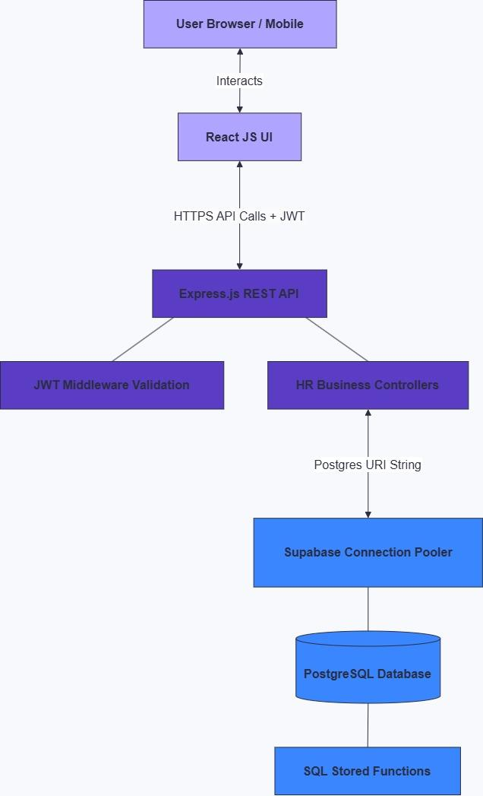
This diagram illustrates the decoupled client-server architecture of the HRMS. The frontend is built using React JS, which provides a responsive user interface. It securely communicates with the Node.js/Express application server via REST APIs, authenticated by JSON Web Tokens (JWT). The backend server processes the business logic and executes data operations on the centralized MySQL database, ensuring that the database is completely isolated from direct public internet exposure.

- Network Security / Deployment Diagram
This diagram demonstrates the network routing rules and security layers protecting the system. External users interact with the system via encrypted HTTPS connections routed through an internet firewall. The web server handles frontend requests, while backend API requests are internally routed to the application server. The application server is the only entity permitted to communicate with the MySQL Database through a secure, encrypted internal connection, preventing unauthorized external access to the data core.

- Entity-Relationship Diagram (ERD)
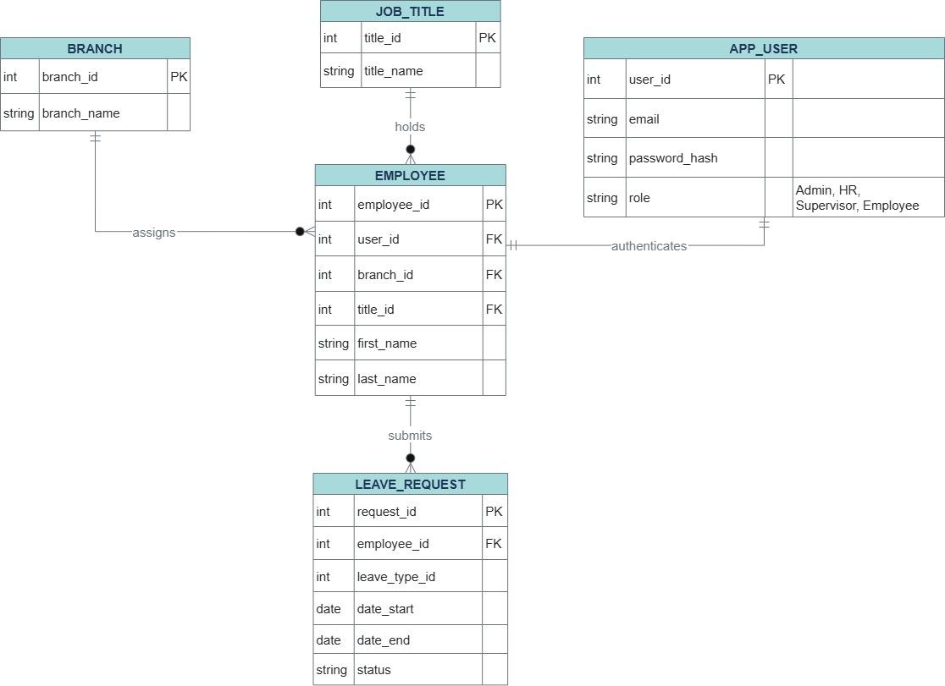

The ERD visualizes the normalized MySQL database structure that serves as the foundation of the HRMS. It dictates the relational mapping between critical entities—primarily showing how specific `Roles` are assigned to `Employees`, and how those `Employees` submit and manage `Leave Requests`. This structured normalization prevents data redundancy and securely links authentication credentials and permissions directly to the employee records.

- Use Case Diagram
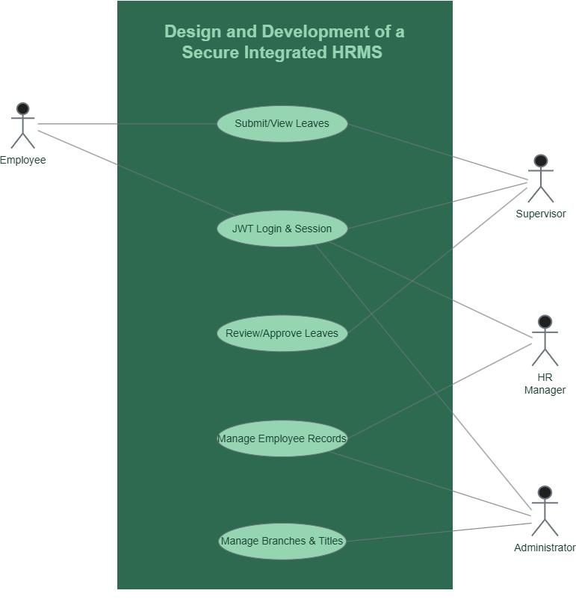
This diagram maps out the core Role-Based Access Control (RBAC) boundaries. It visually defines the specific capabilities granted to each identified actor within the system—Employee, Supervisor, HR Manager, and Administrator. For instance, while an Employee can only apply for leaves and view personal data, a Supervisor receives the authority to approve leaves, and an Administrator governs system-wide configurations. This establishes visual proof of the system enforcing the Principle of Least Privilege.

X. TESTING AND EVALUATION

Security Testing
- Types of Tests:
Role-based authorization tests, API endpoint security tests, XSS and SQL injection vulnerability assessments.
- Tools:
Postman for API testing.
- Results Summary:
Verified that unauthorized tokens are rejected and unauthorized role elevation is prevented by the backend.

Evaluation Criteria
- Performance: API response times under varying load.
- Security: Resilience against unauthorized data access attempts.
- Usability: Intuitive user interfaces across devices.
- Reliability: System uptime and secure session continuity.

RISK MANAGEMENT AND INCIDENT RESPONSE

Purpose:
Prepares the system for unexpected problems.

Risk Management Plan What to write:
    - Identified risks
    - Mitigation strategies
    - Monitoring plans

Incident Response Plan What to write:
    - Detection
    - Reporting
    - Containment
    - Recovery steps

PROJECT SCHEDULE / TIMELINE
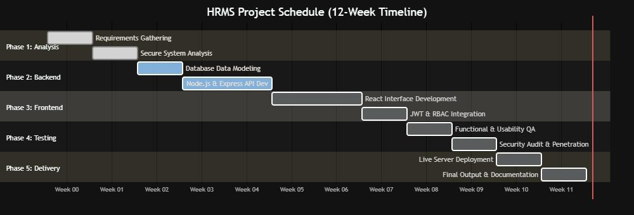

COST AND RESOURCE REQUIREMENTS
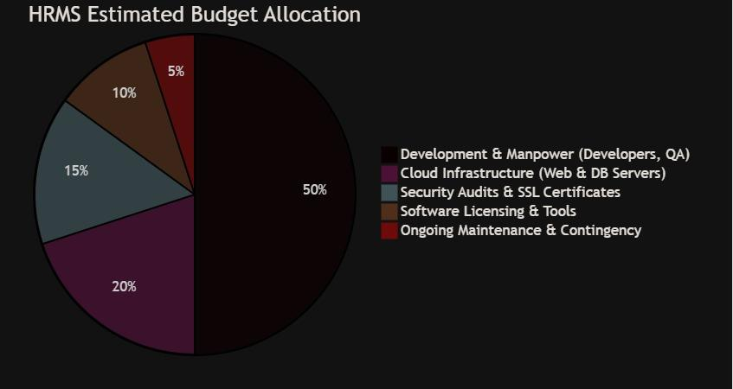

EXPECTED OUTPUTS AND BENEFITS
- Functional System: A centralized intuitive digital HR platform.
- Documentation: Comprehensive deployment and system architecture guides.
- Security Improvements: Secured employee data, elimination of paper-trail vulnerabilities, established audit logs.
- Organizational Benefits: Increased operational efficiency, improved administrative productivity, single source of truth for HR.

CONCLUSION AND RECOMMENDATIONS
The Secure Integrated Human Resource Management System significantly upgrades the traditional fragmented, manual HR operations into a centralized, highly secure digital infrastructure. It successfully automates leave tracking and employee management while robustly enforcing Role-Based Access Control and data encryption standards. For future iterations, introducing automated payroll integration, multi-factor authentication (MFA), and a native mobile application are highly recommended to further enhance security and user experience.

REFERENCES
- NIST Guidelines on Access Control and Authentication.
- Relevant Academic Journals on Human Capital Management and Data Privacy.
- Official Node.js and React Security Documentation.

